NEXCORE
A L L I A N C E
nexcoreaIIiance.com +91 897 632 2917 | 720 806 2689 CIN NO - ACK-7603
director@nexcorealliance.com | hr@nexcorealliance.com

Nexcore Alliance LLP Mumbai, India
Date: 30 / 10 / 2025

Subject: Experience Certificate — Fayyaz Abdul Rahaman Khan

To Whom It May Concern,
This is to certify that Mr. Fayyaz Abdul Rahaman Khan was associated with Nexcore Alliance LLP under its brand Code4Bharat as a Junior Software Developer from 31st May 2025 to 30“ October 2025.

During his tenure, he contributed to basic development tasks and project-related activities under supervision. His technical skills were observed to be at a developing level, requiring additional guidance and mentoring to meet expected standards.






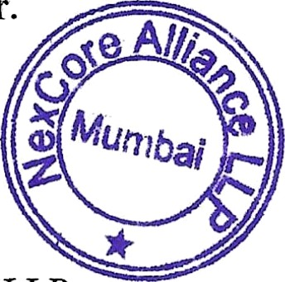

s,
Director (CEO),
Nexcore Alliance LLP
director@nexcorealliance.com

